1. Please fix the memory leak.
2. Crashes
   1. The program crashes when left open long enough
      1. This happens even using less than 1gig of my ram, so I don’t know if its because of the memory leak or for some other reason. If its for another reason then its pretty important to figure out the cause
3. Flow
   1. Annotation of an image should only be possible after selecting the image from the right side panel. So: select image -> the live camera view is replaced by the selected image -> annotations made by user -> image saved
   2. The original image should be saved in addition to the annotated image.
      1. This is because annotations might overlap some essential features of the image so the original unaltered image should always be saved first, and the annotated image saved as a new image.
   3. After clicking the Capture image button, the captured image should replace the live camera view for 500 millisecond, and then the live view should resume.
      1. This is so the user has visual feedback that an image was captured. It is possible that a person who isn’t great with computers may not notice the new thumbnail appearing in the bottom right of the screen so an additional visual signal is needed.
4. Menu
   1. Add a drop down menu to the top left of the screen called “settings”
      1. Option to set a destination to the directory patient folders will be created
         1. (ME): set this via a file dialog??: like this one <https://github.com/dfranx/ImFileDialog> (PRIO:2)
      2. This directory should be saved somewhere so the user doesn’t need to set it each time they launch the application
5. Lincesing:
   1. Change the date to the end of march (PRIO 3)
6. Saved Images / Live camera
   1. All images need to saved with an overlay or watermark of the patients Unique ID, image number, time and date (PRIO:3)
   2. 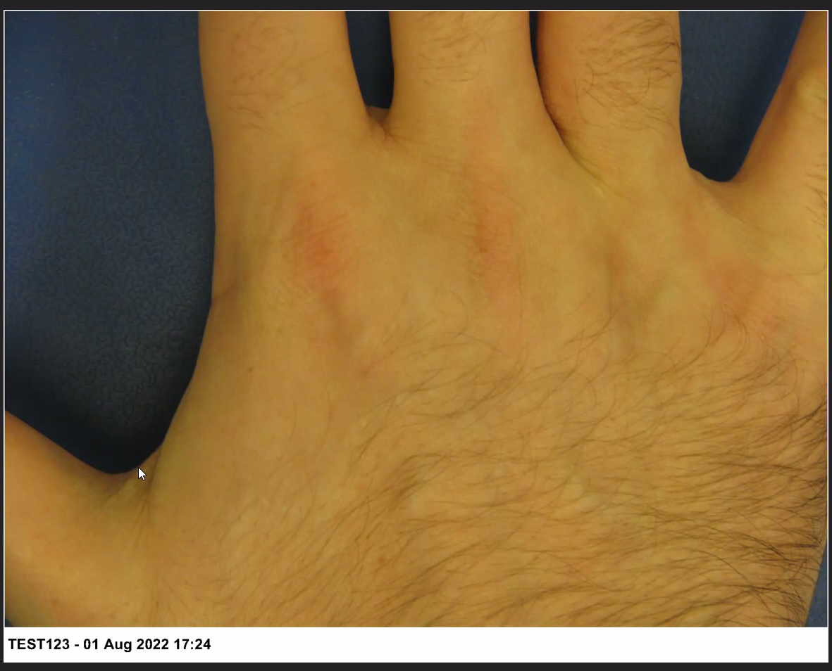
   3. Currently saving images at 640x480, should be 1920x1080
      1. How would the program handle a webcam with less than 1080p resolution?
   4. Live camera view should also be 1920x1080
   5. Bug: if a directory already exists, the program throws an error “can not create directory” instead of just accessing the directory and displaying the images in the right side panel
7. Text input
   1. make enter button work
   2. the text should not be cleared after pressing enter
   3. the patients ID should always be visible within the text box
   4. add 2 small buttons next to the text input – one that says “Submit” and the other “Clear” – submit should be the same as pressing enter. Clear – clears the text input
   5. If possible, make the blinking cursor centred in the text input
   6. move to bottom of window (below camera stream)
   7. allow letters and special characters (except single and double quotation marks - anything which will end a string and cause a crash)
   8. make it font size HUGE - at least size 48 font
8. Window
   1. Set a minimum window size (approx. half screen width and half height or whatever feels appropriate - make sure to maintain HD aspect ratio) – only resizable at the edge(if not working with SDL: two gui size: fullscreen, smallscreen – button for that in the corner)
   2. Window - Is it possible to remove the triangle in the top left corner of each imgui window?
   3. Window - Set a fixed size for each of the 3 imgui windows (maximise camera stream) -
   4. Window - maintain aspect ratio of imgui windows when resizing the main windows window (maybe set the main windows window to only be fullscreen windowed mode or 1/4 screen so it has only 2 sizes which ever is easier for you)
   5. I know this is part of the docking branch but if possible prevent imgui window from being able to leave the main window
9. Buttons
   1. Make all the buttons except "Capture Image" greyed out (inactive/unclickable). Only if an image is selected from the image strip on the right do the other buttons become active
   2. Delete button – with pop up confirmation
   3. Print button - print the image to the default printer (PRIO 4)
10. Delete image
    1. Do not make delete button on the keyboard work for deleting images as this could result in accidental deletion of an image (which is a very big deal - medical images are considered legal documents)
    2. When an image is deleted - a pop-up should appear asking the user if they are sure they want to delete
11. Cursor feels laggy - from memory there is an option in imgui to stop the cursor from being rendered by dx11 itself
12. Thumbnails
    1. Change aspect ratio of thumbnail images to be closer to HD/wide screen aspect
    2. The right side panel with the thumbnails in it, should scroll down automatically as new images are taken (so that the most recent image is visible)
       1. Having the most recent captured image appear at the top of the scroll bar isn’t an option for reasons.
    3. Load the images from the folder if it was created beforehand (PRIO:1)
13. Toolbar:
    1. Screenshot icon in full size, the others in a two rows layed out plainly (PRIO 5)
14. Annotation
    1. After drawing a line/circle/arrow/rectangle, the tool should still be active so that another line can be drawn without having to reselect the same tool again
       1. At present, each time you want to draw a line, the line tool needs to reselected
    2. Change default colour to red – make it brighter red(Ferrari red) (PRIO 5)
    3. Default text colour should be black with a solid white background (PRIO 5)
    4. Ideally (maybe in the next contract) – ability to change line colour, thickness, text size
    5. The circle appears pixelated. Is it possible to increase the resolution of the annotation layer to HD
15. History scroll
    1. Under the annotation buttons have a scrollable list of previously entered patient IDs
       1. It is possible a user will need to go back and forth between a number of patients so this will make it easier to switch patients without having to enter the ID each time. The list should show the last 20 created patient folders
       2. This list doesn’t need to be saved between launches of the program, but if it can be done easily then why not (PRIO 5)